**Assignment : 11**

**Build scaling plans in AWS that balance the load on different EC2 instances.**

1. Login int AWS account and create a template. Select Ubuntu in quick start.

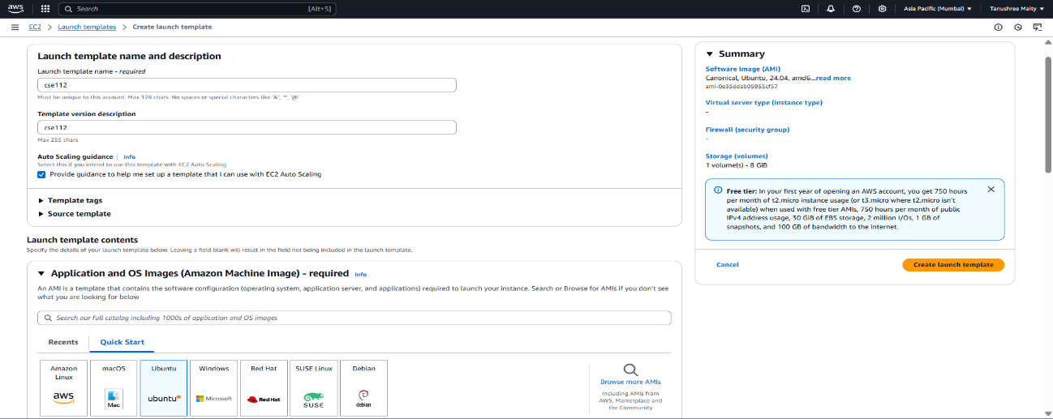

1. Select key pair and select existing security group in Firewall (security groups).

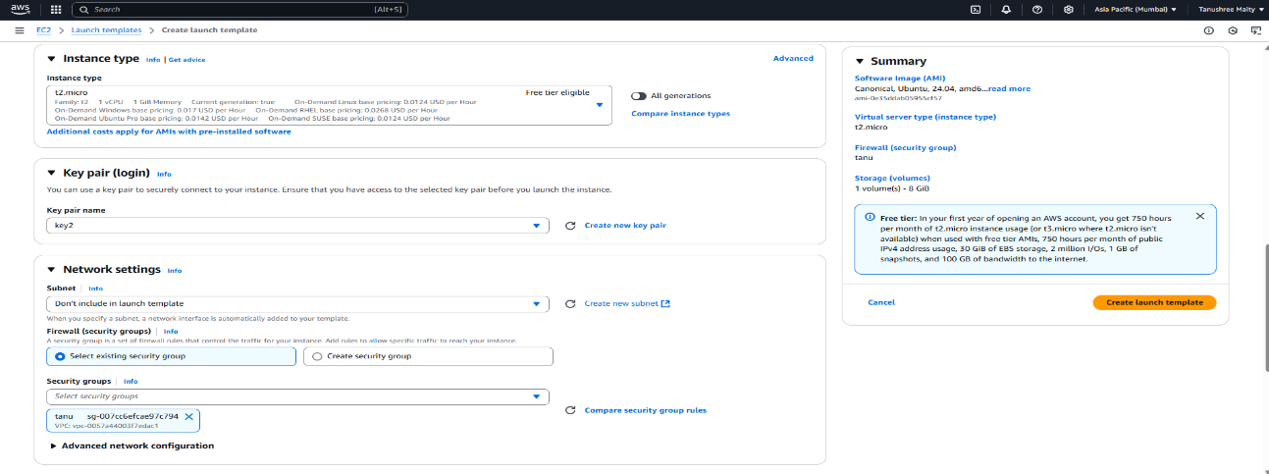

1. After Selecting security group go to the user data and write given cmd. Click launch instance.

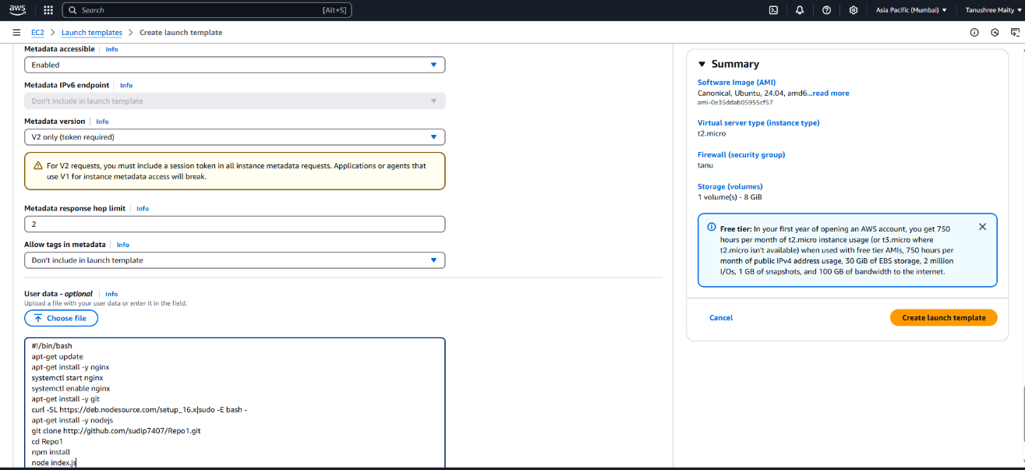

1. Create auto scaling group, enter name for auto scaling group, select template, click on next.

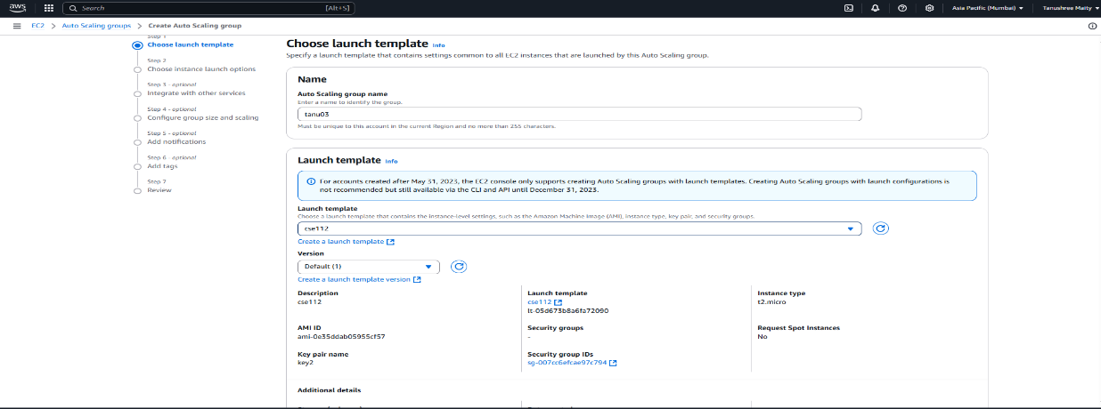

1. Now select all availability zones and subnets then click on next.

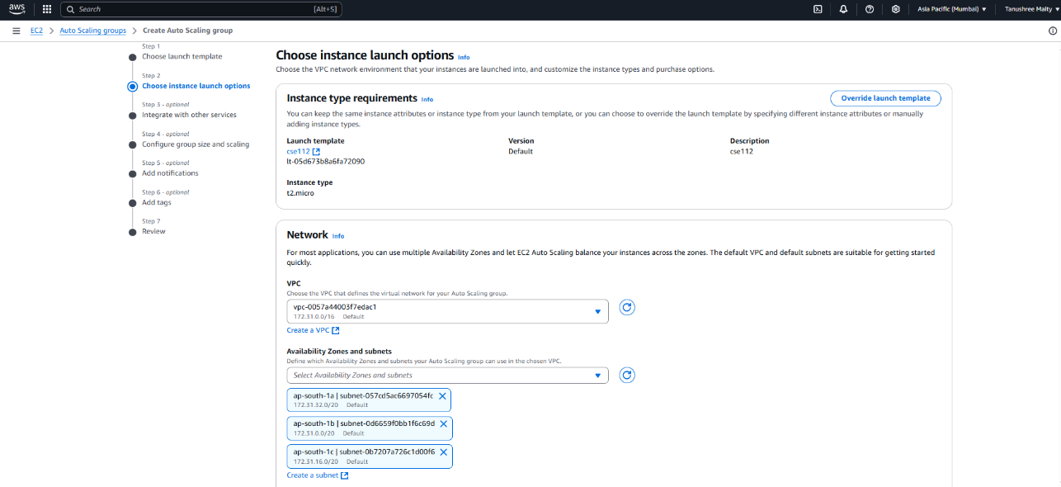

6. In load balancing select attach to new load balancer, in attach to new load balancer select aplicatio load balancer, in load balancer select internet-balancing.

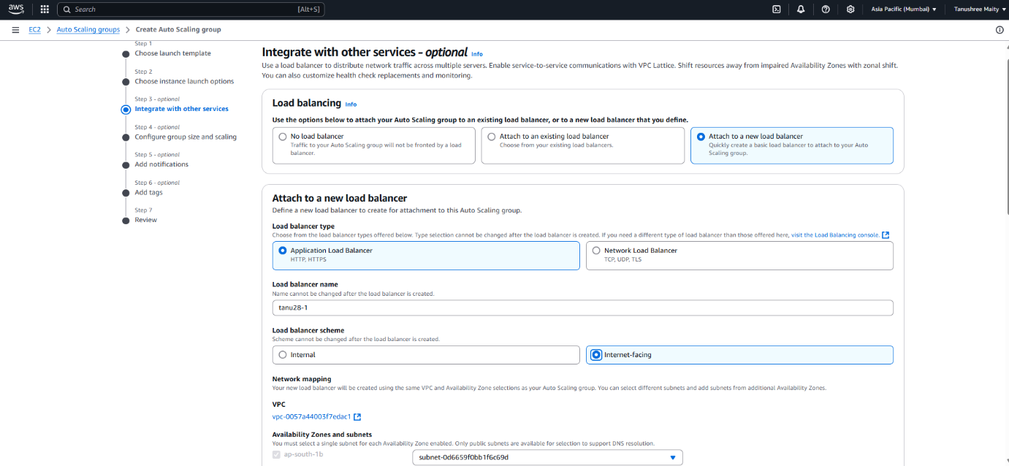

1. In add 1000 in port, select new target group name. In health check period add 200 seconds.

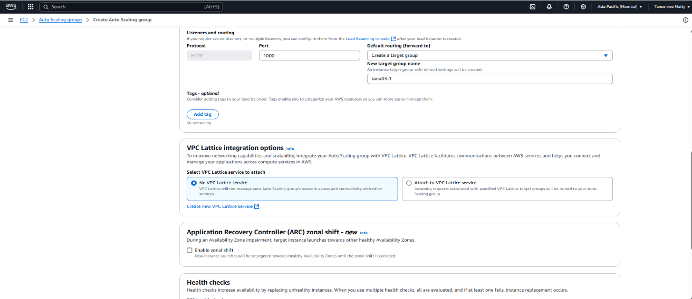

1. In desired capacity write 2. In scaling limit give min 2 and max 3.

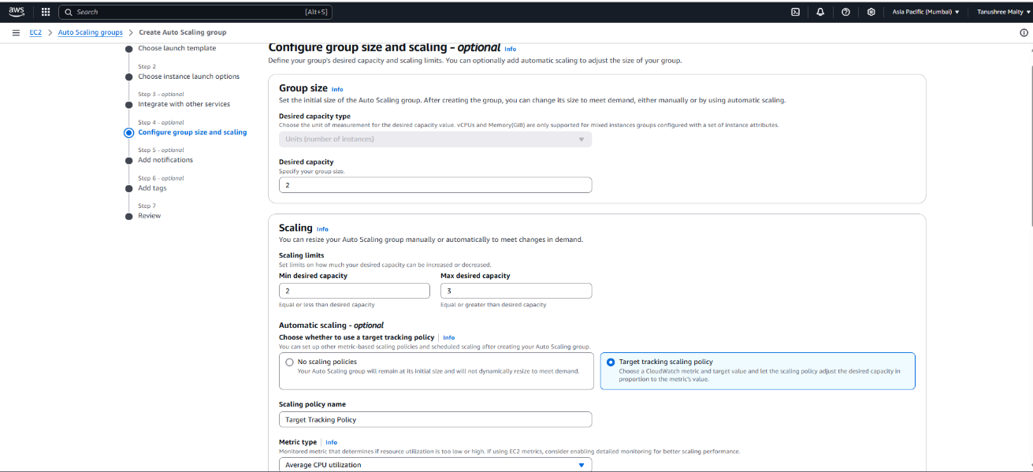

1. In target value as 50, instance warmup as 200 sec. Then click on create auto scaling group.

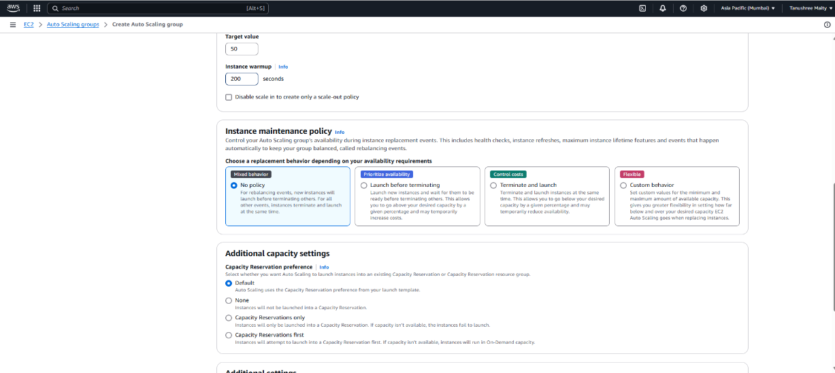

1. Go to load balance copy DNS name and run it in another tab.

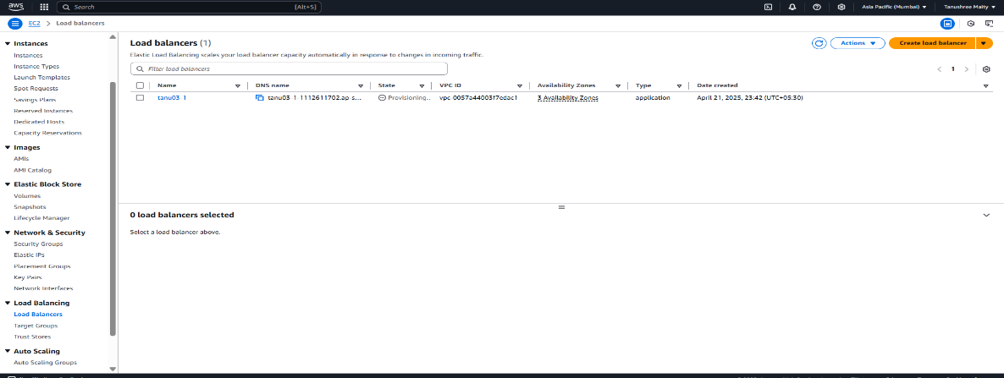

1. Now open bitwise and copy Public IPv4 adress from any one instance and paste it in port. Open terminal and write the given command, it will start a loop.

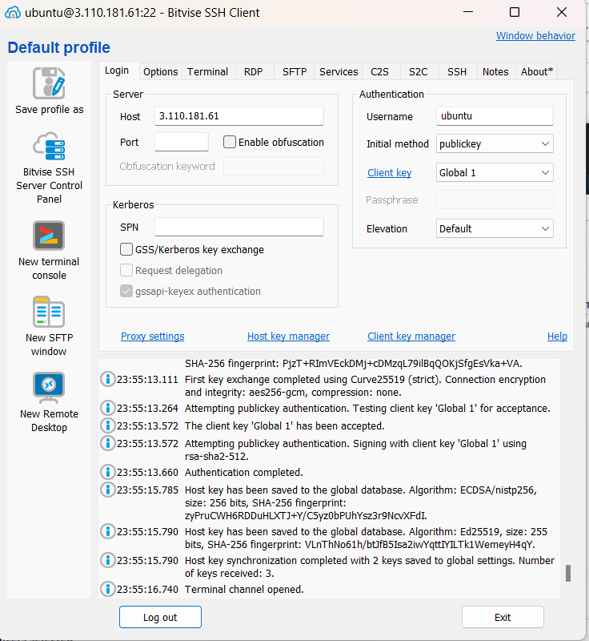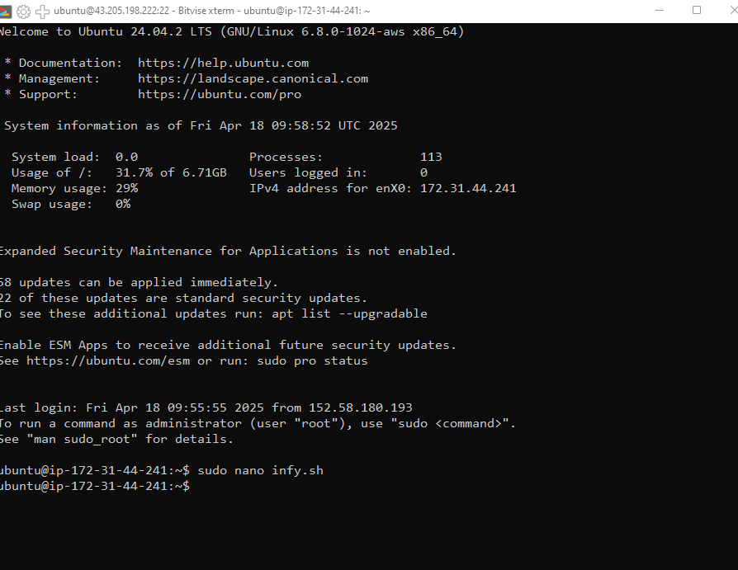

1. In security we can see CPU utilization graph

